Classification of Alzheimer’s Disease Structural MRI Data by Deep Learning Convolution Neural Networks

Ammar Khan
17010020010
Deep Learning Project

Abstract—This paper compares methodologies used in the selected research paper and compares it with 3 different models. The original paper tested 3 CNN models, named LeNet and GoogleNet. The GoogleNet yielded highest accuracy of 98.87 %. The other networks tested by my research yielded accuracy of 97.2%, 98.1% and 99.45 using transfer learning of DenseNet121 , InceptionV3 , and Xception models. All of the models had over fitting problem as the data set was small. The validation accuracy for all models were below 60%.

Summary
Alzheimer's disease is a neurological condition that slowly evaporates the memory by destroying the brain cells and messing up the neural network of the active person over the passage of time. This condition could lead to cognitive decline in early phase, like forgetting to do simple tasks or maybe losing the capability of doing the task, and in the later stage causes dementia. The structural MRI data is used in this paper to diagnose healthy tissues of brain from the diseased/affected one. The papers suggests CNN to distinguish between both. CNN is proffered as an architecture to carry out classification in this case, because the cortex which processes sensory information has similar architecture as of CNN model. Data set used for this model is ADNI MRI Database which contains 302 records, 211 healthy and 91 diagnosed with Alzheimer .

Methodology
First, the data set was converted to ‘png’ format. The final data set contained 62335 images. 52507 were classified as ‘AD’ (Alzheimer Disease), and the remaining 9828 where classified as NC. The data set was converted into high performance ‘LMDB’ format to increase learning speed. Training for all models comprises of 75% training and 25% testing data. For the purpose of training LeNet model, the images were rescaled to 28*28. The model was set to 30 epochs, used Stochastic Gradient Descent with gamma = 0.1, momentum = 0.9, base learning rate = 0.01, weight decay = 0.0005, sigma = 3mm and Step learning rate policy. The accuracy yield of the model was 98.79%. The GoogleNet model was resized to 256*256 with 30 epochs,Stochastic Gradient Descent with gamma = 0.1, momentum = 0.9, base learning rate = 0.01, weight_decay = 0.0005,sigma = 3mm , and Step learning rate policy. The model accuracy yield was 98.8431%.
To cross validate my own models, I used a publicly available data set from OASIS, which is similar to ADNI, but has no tedious applications procedure to acquire data set. All base input images where scaled to 75x75. Transfer learning was used to embed ‘DenseNet121’, ‘InceptionV3’ and ‘Xception’ as base layers for three different models. The architecture for these base models are as follow.

Figure 1: DenseNet121 Architecture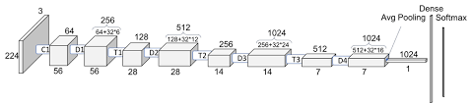

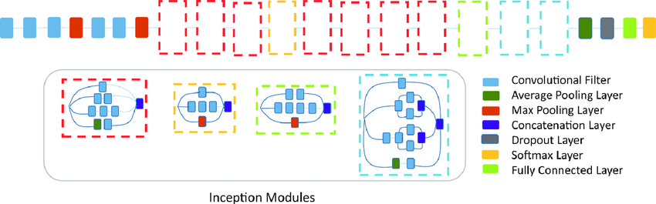Figure 2: InceptionV3 Architecture

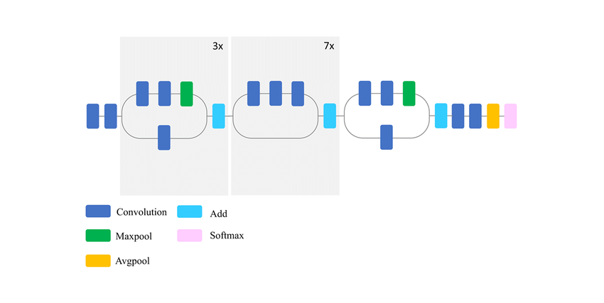Figure 3: Xception Architecture

After these base models, a flatten layer was added to vectorize 2D images. The next layer is Batch Normalization which standardizes all the input images to a fixed pixel ratio. The next layer is a Dense layer with 512 neurons with ‘he_uniform’ as activation function. The last layer uses 1 neurons and sigmoid function as activation for classifying between AD and NC. Training and Validation split was 0.2, epochs = 10, batch size = 20, optimizer used was Adam with learning rate of 0.001.

Results and Conclusion
The training and validation graphs for each model is as follow:
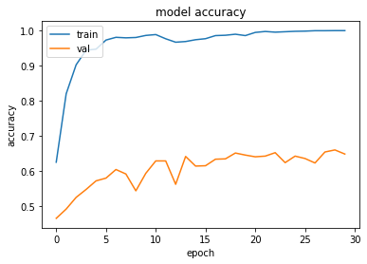Figure 4: DenseNet121
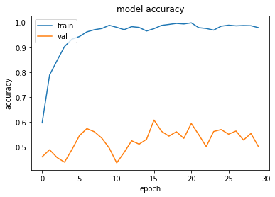Figure 5: InceptionV3
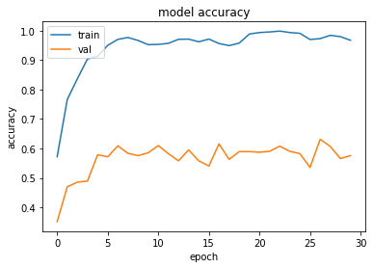Figure 6: Xception
The Densenet121 yielded most stable results, on the other hand, validation results for all of these models were not satisfactory.

References

- Classification of Alzheimer’s Disease Structural MRI Data by Deep Learning Convolutional Neural Networks, 2016.
- Xception: Deep Learning with Depthwise Separable Convolutions, 2017.
- Rethinking the Inception Architecture for Computer Vision, 2015.
- Densely Connected Convolutional Networks, 2018.

